How to Create Setup Cards in SMS3000
To create setup cards in SMS 3000 you will need:
- Lenovo Smart Card Reader
- 1K Smart Card (PocketBook)
- SMS 3000 login credentials
- Smart Card Interface Tool v1.0.0.3

- Using Google Chrome login to https://www.sms-3000.com/ using your login credentials
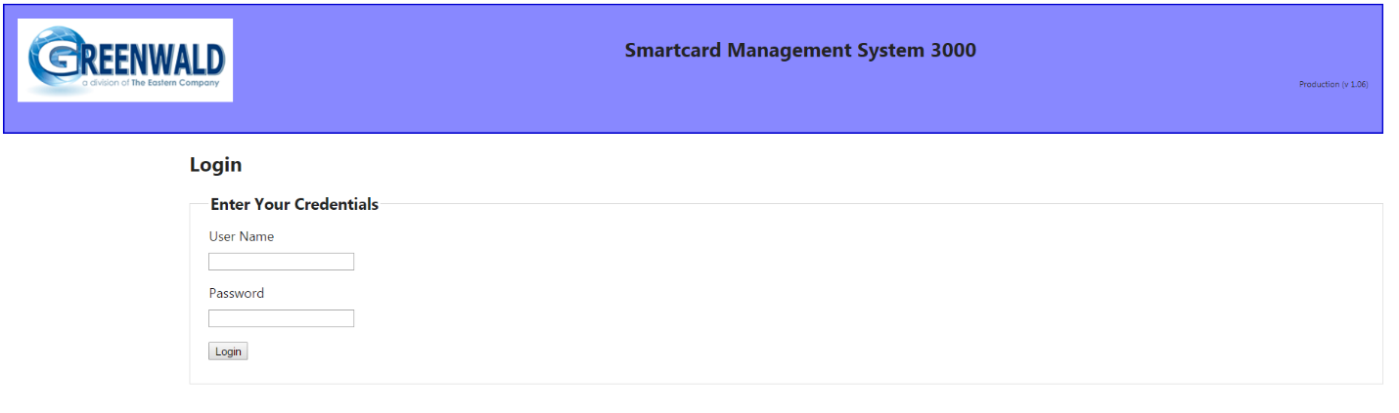
- Select Card Profiles: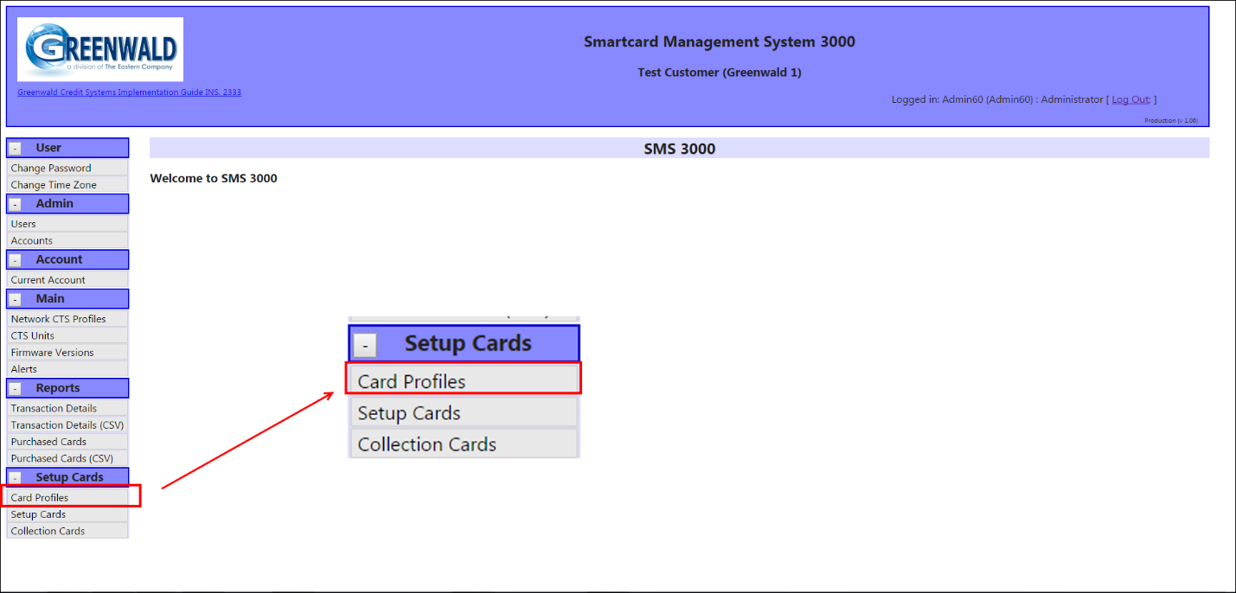
- Select the desired Profile Type from the drop down menu and then select the Create Profile button:
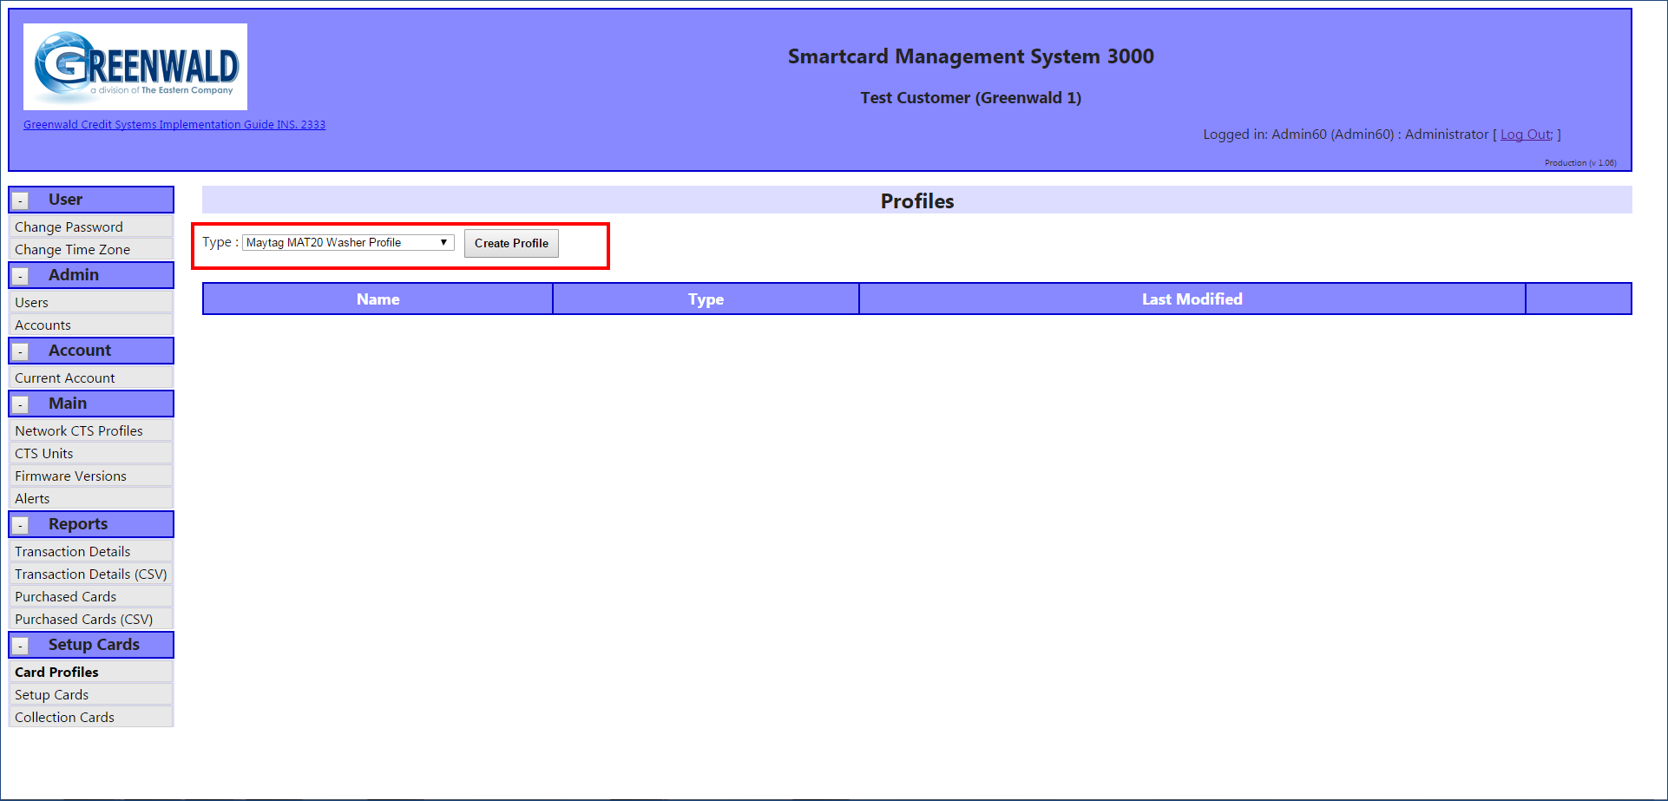
- Enter new profile name (Example provided for MAT20, other settings may vary depending on machine type selected):
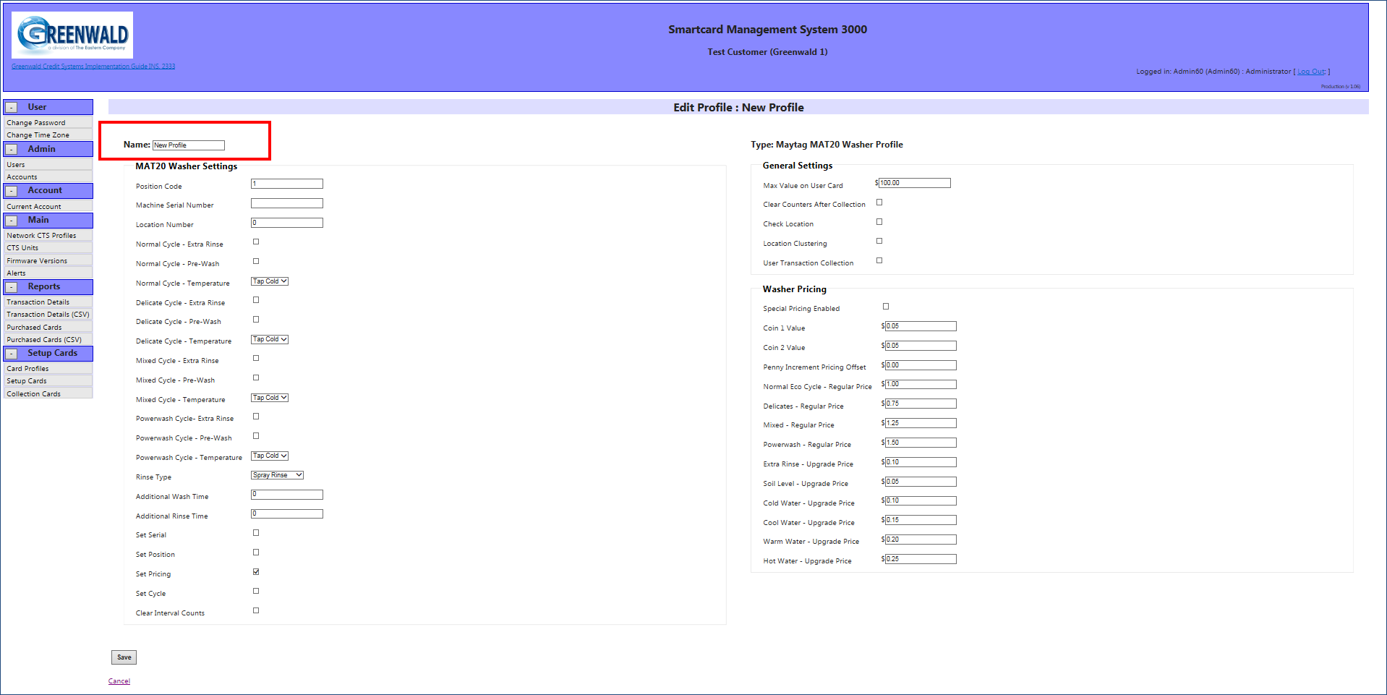

- Fill in Machine Settings, General Settings and Pricing Settings for the selected machine profile type and scroll to the bottom of the page to save.
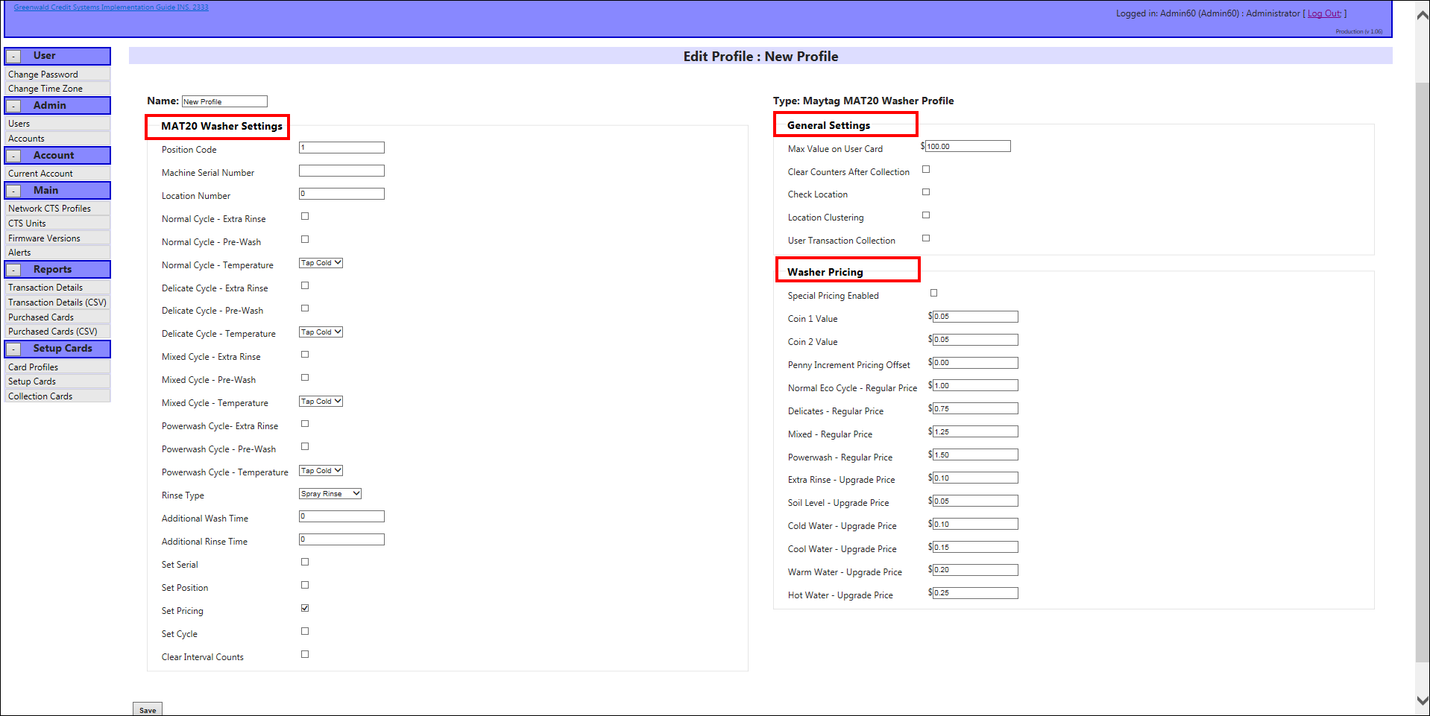
- Scroll to bottom of page and select “Setup Cards”:
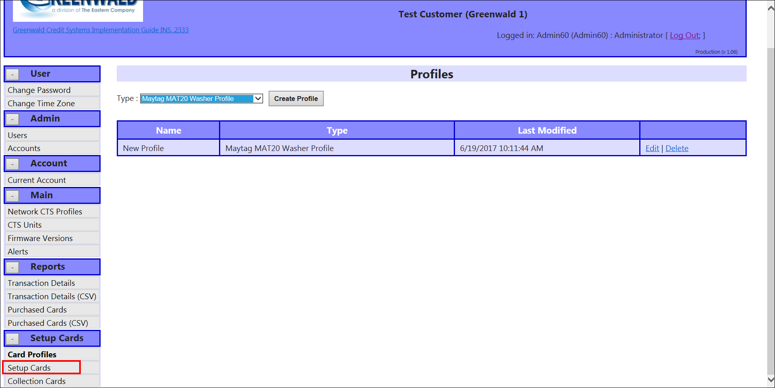

- Select New Setup Card.
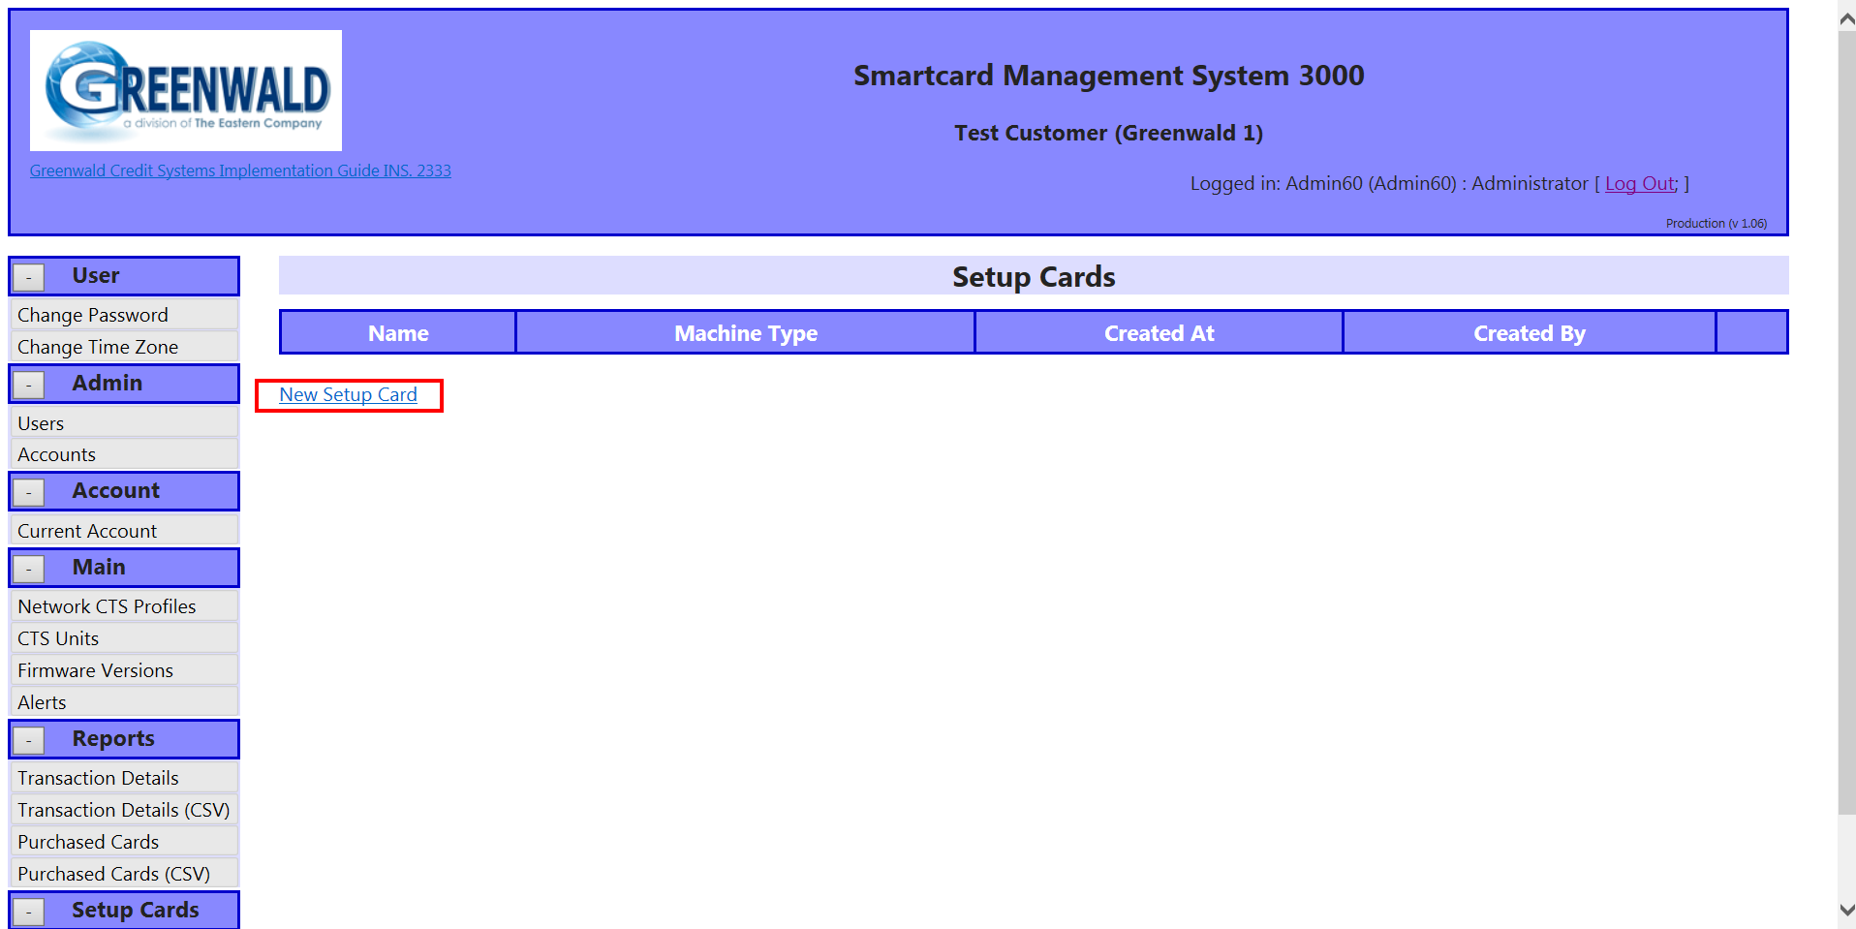
- Enter Setup Card Details
  - Full Name and Select Card Profile (if multiple profiles have been created a drop down list will appear).
  - Enter Location ID and Machine ID.
  - Click the Create Setup Card button.
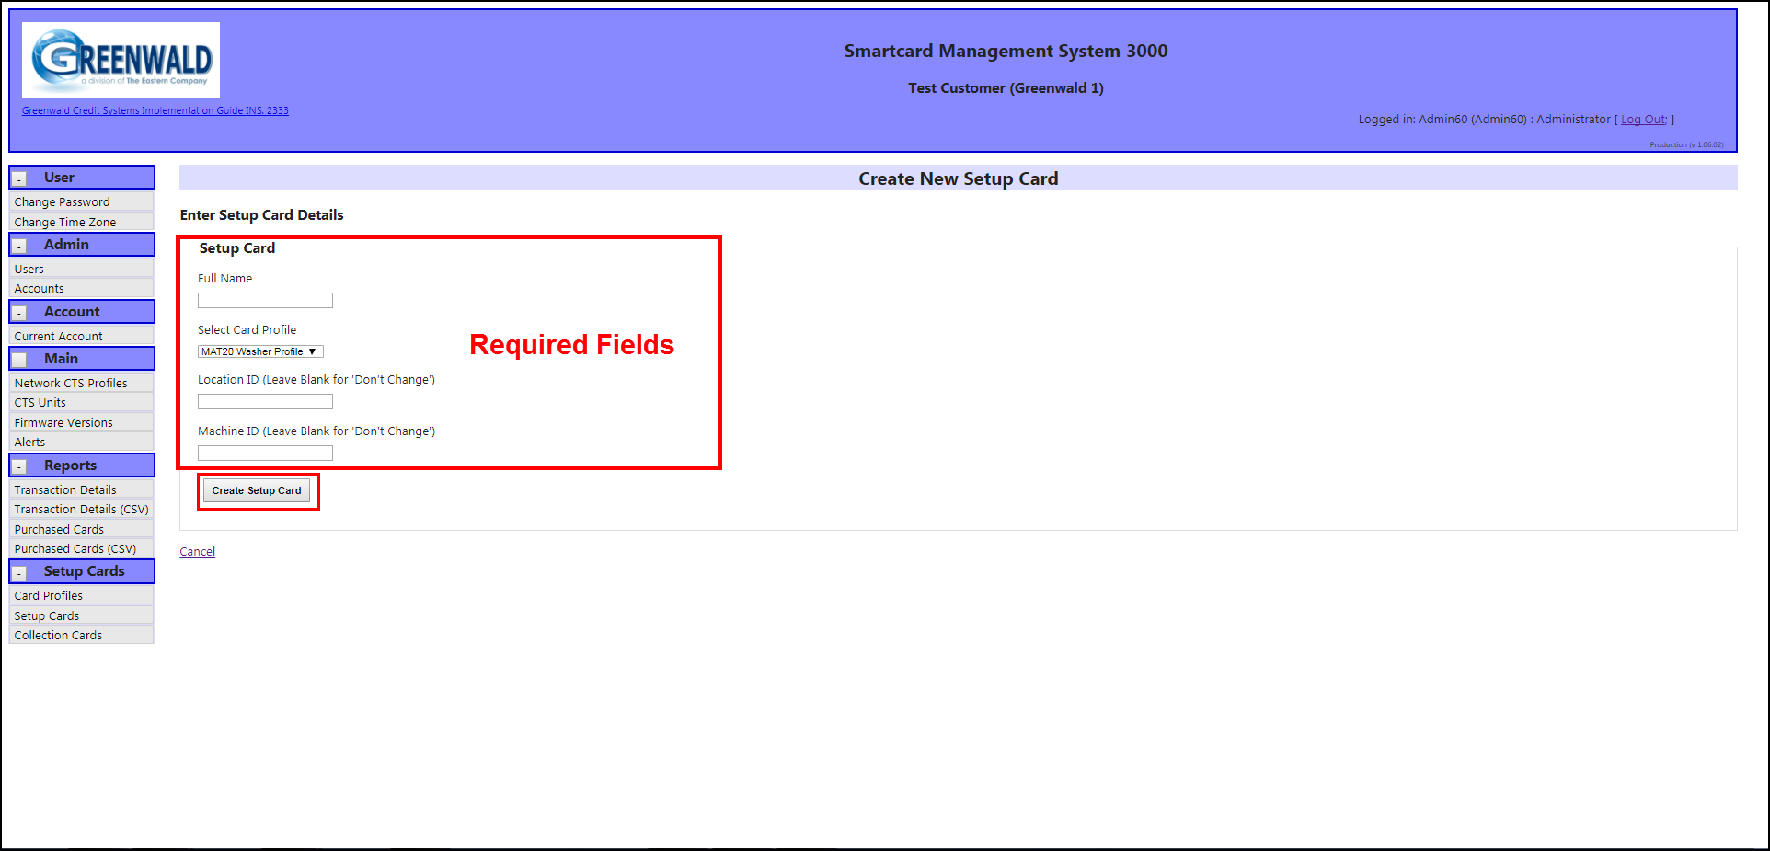
Installing the Smart Card Interface Tool v1.0.0.3
- Plug in thumb drive provided by Greenwald Industries and drag “Smart Card Interface Tool v1.0.0.3” to desired location on computer.
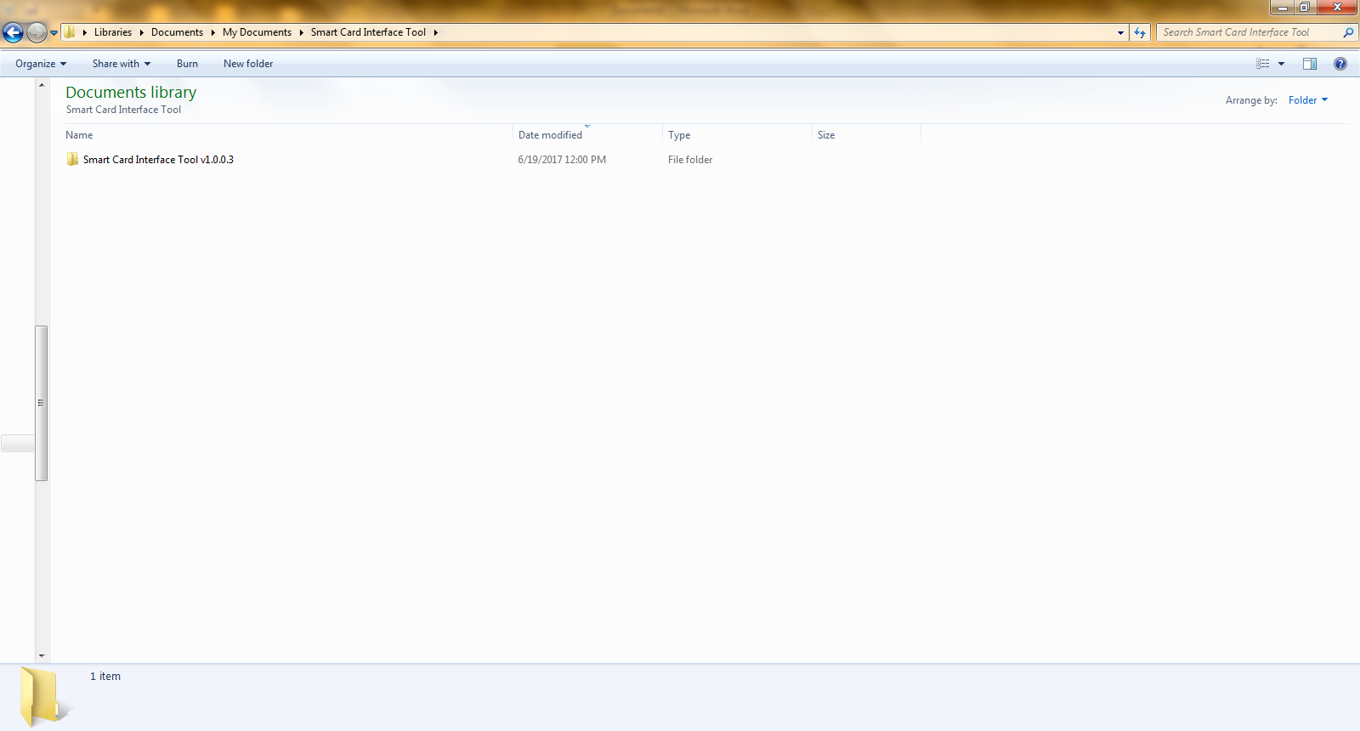
- Open folder and double click on “SmartcardInterfaceTool.exe”:
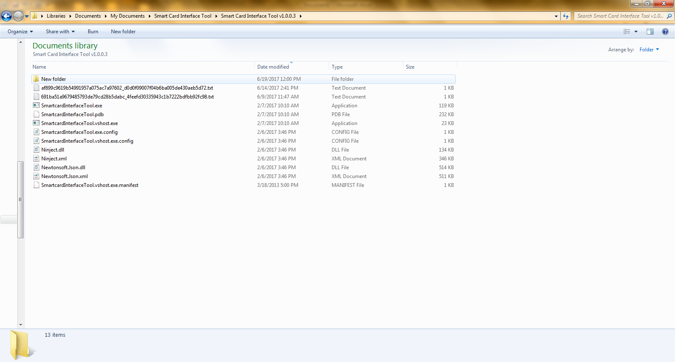
- Login using same credentials used to logon to SMS3000:
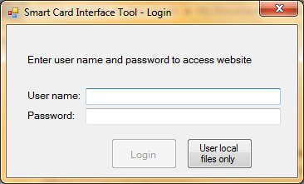
- Select “Download Image List”.
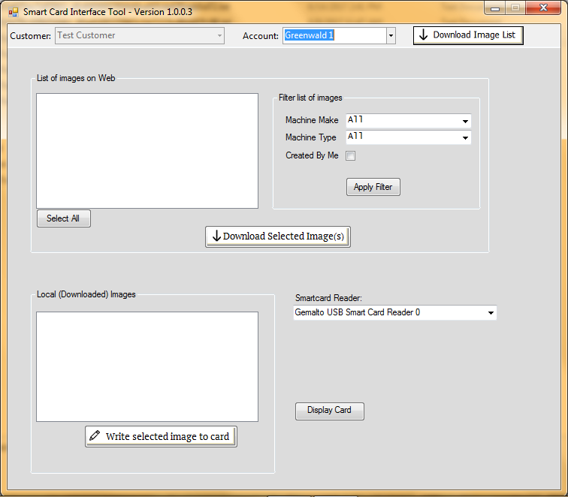

- Select image from “List of images on Web” window:
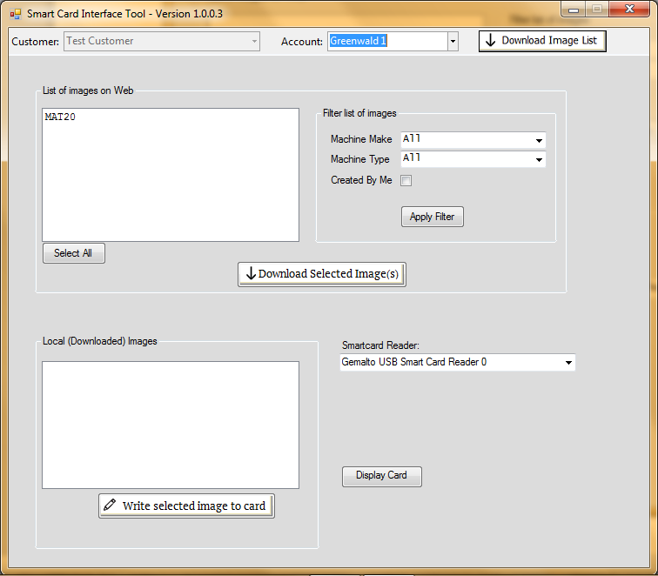

- Select “Download Selected Images(s)”
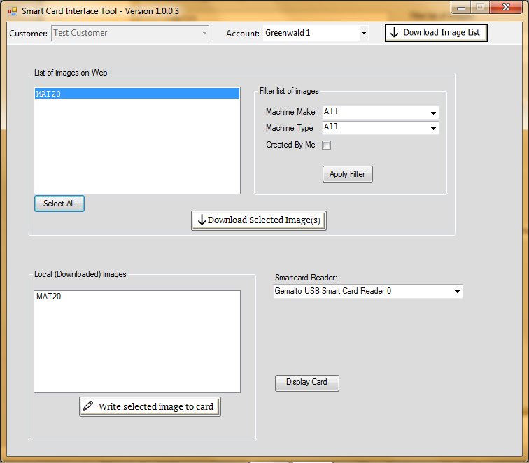

- Select image from “Local (Downloaded) Images”
  - Insert setup card into Lenovo card reader
  - Select “Write selected image to card”:

- Select “OK”
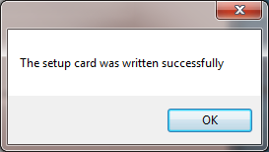
- Remove programmed setup card and use to setup selected machine type.

